Załacznik 2
Panorama of Warsaw seen from the right bank of the Vistula River | 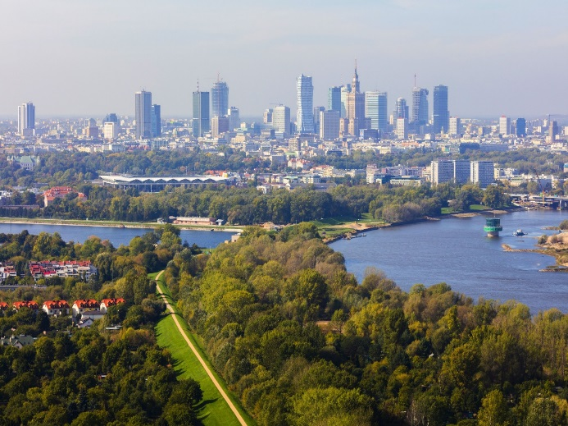
The mouth of the Vistula to the Vistula Lagoon | 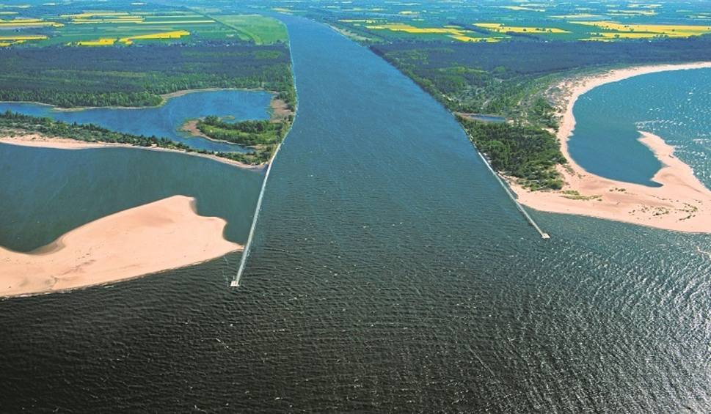
Source of the Vistula River on the slopes of Barania Góra | 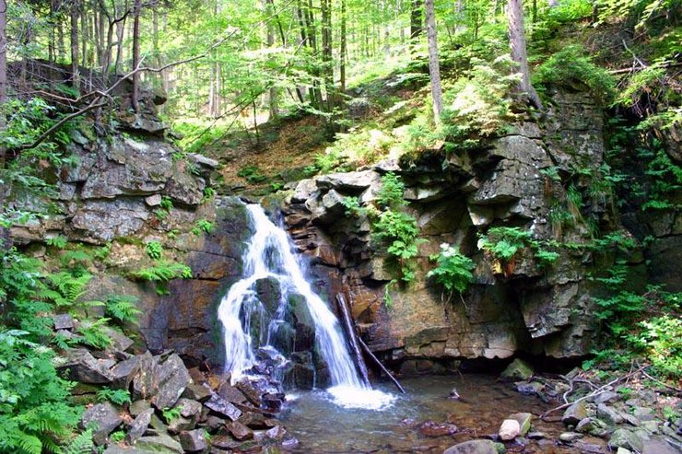
Visible sandbanks on the Vistula River in Annopol | 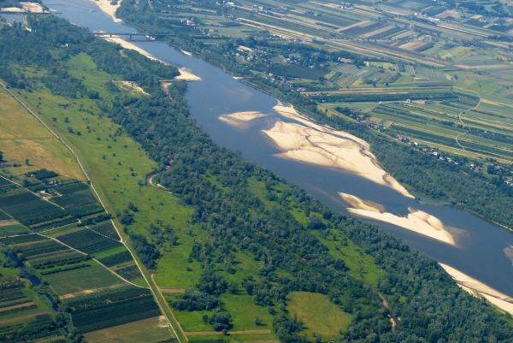
The high bank of Vistula River in Płock | 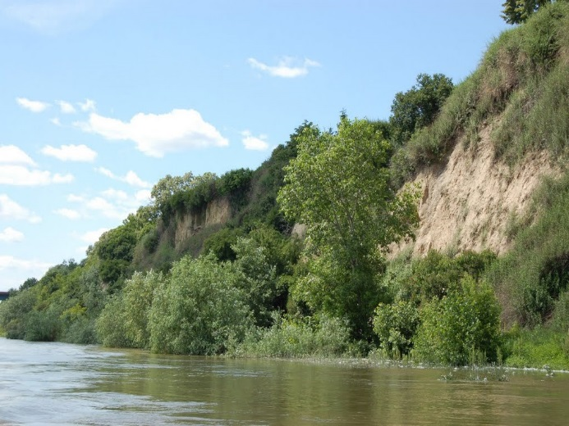
Course of the Vistula River marked on the map  of Poland | 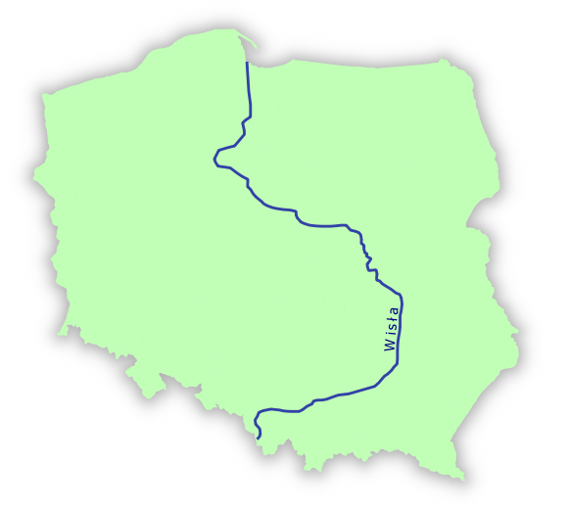
Common gull on the banks of the Vistula River in Warsaw | 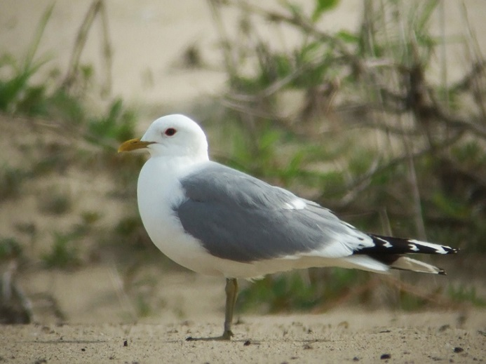
Little tern on the banks  of the Vistula River  in Warsaw | 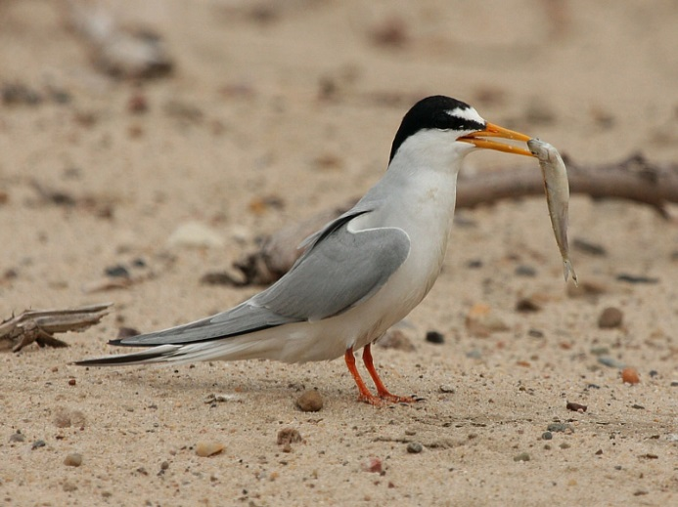
A pair of mallard ducks | 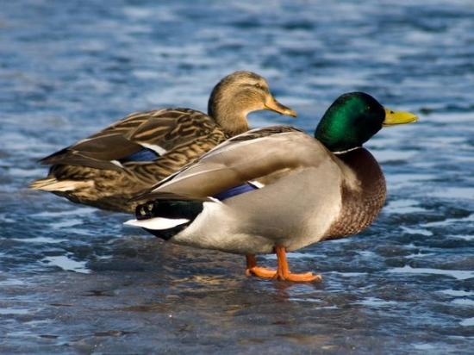
Riparian forest growing on the banks of Vistula River | 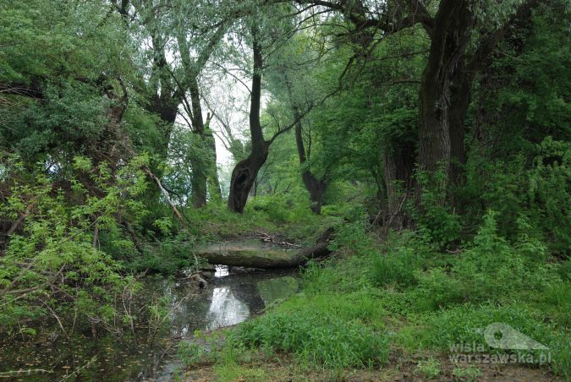
Canadian waterweed - plant growing on the bottom of the Vistula River | 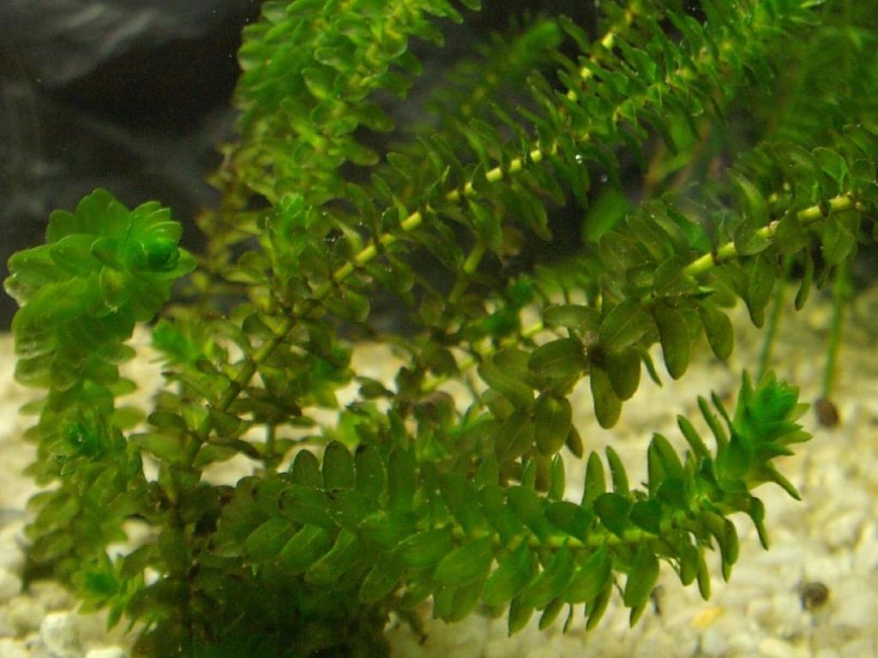
Pike caught in the Vistula River | 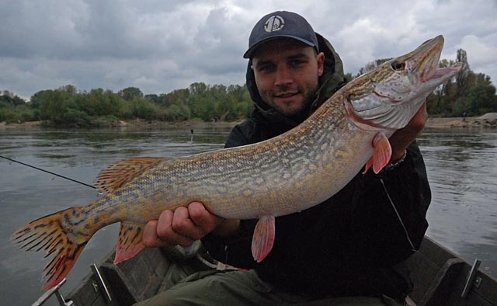
The Royal Castle in Cracow on the bank of the Vistula River | 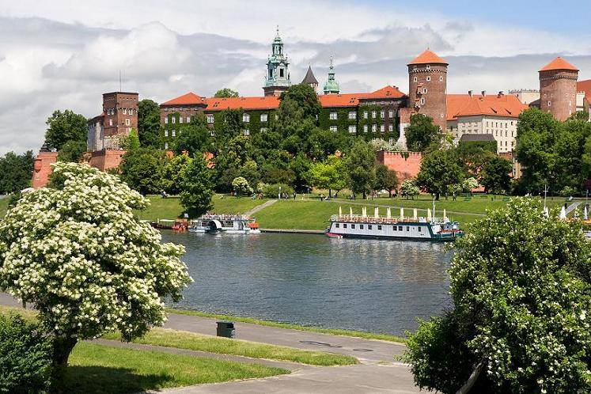
Teutonic knights’ castle in Malbork | 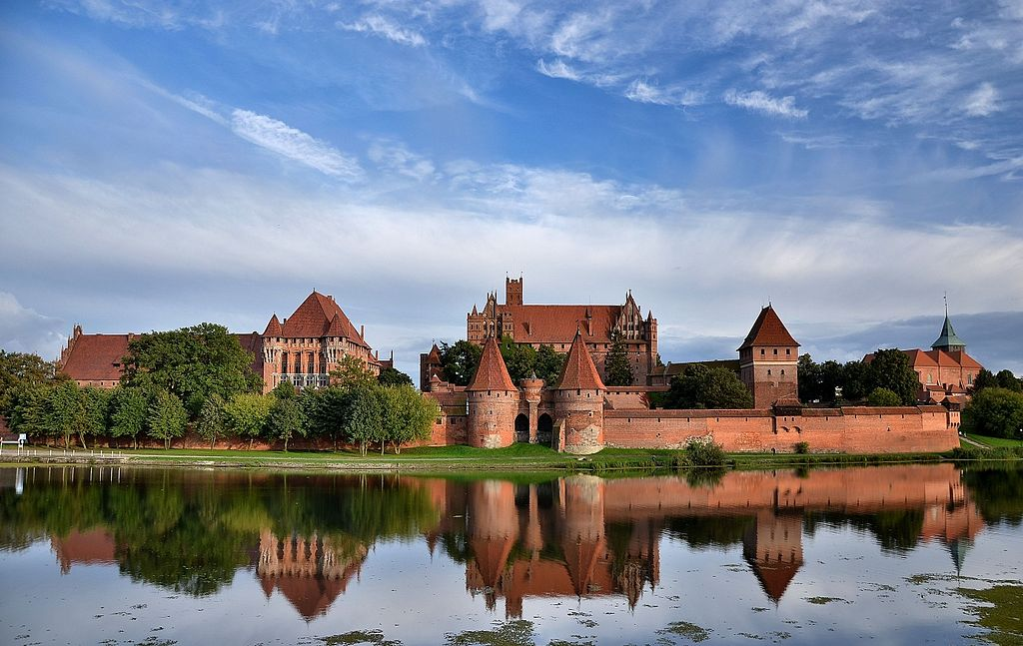
Meandering Vistula River | 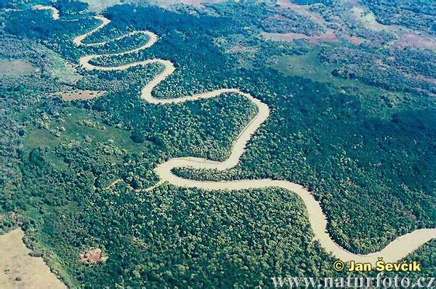
Oxbow lakes of the Vistula River near Cracow | 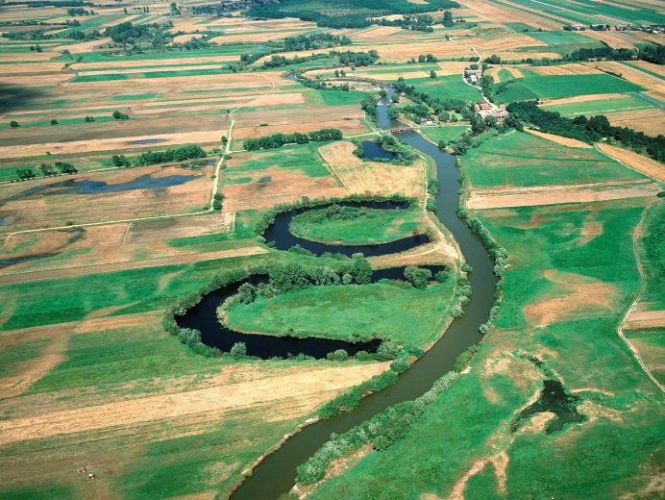
European beaver on the way to the football game | 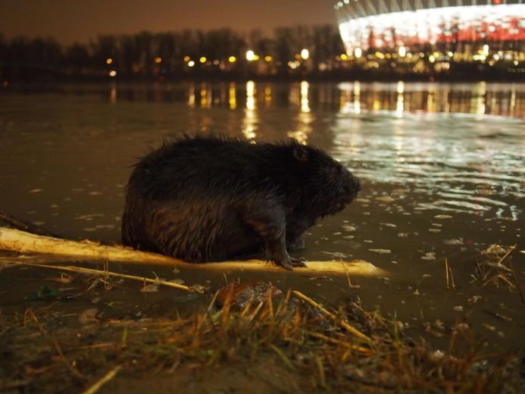
Great flood in Sandomierz in 2010 | 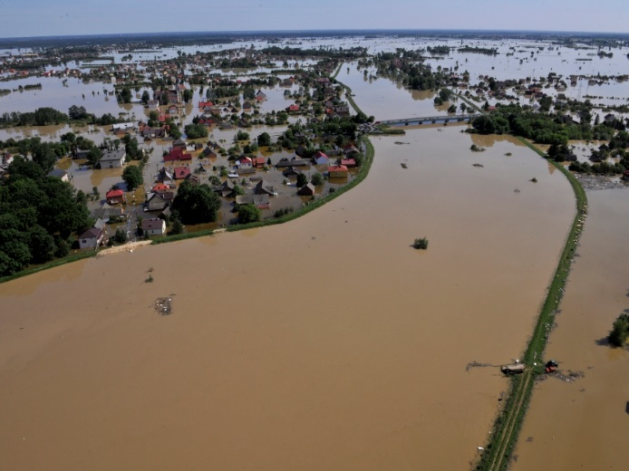
Profile of alluvial soil | 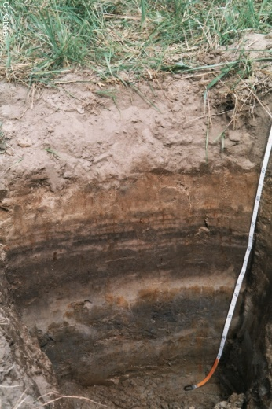

GAME OF MATCHING - VOCABULARY

banks – brzegi
bottom of the Vistula River – dno Wisły
canadian waterweed – moczarka kanadyjska
common gull – mewa siwa
course of Vistula River – bieg Wisły
european beaver – bóbr europejski
football game – mecz piłkarski
great flood – wielka powódź
high bank – wysoki brzeg
little tern – rybitwa białoczelna
mallard ducks – kaczki krzyżówki
meandering – meandrująca
mouth of the Vistula – ujście Wisły
oxbow lakes – starorzecza
panorama – panorama, widok
pike – szczupak
profile of alluvial soil – profil mady rzecznej
right bank – prawy brzeg
riparian forest – las łęgowy
Royal Castle – Zamek Królewski
sandbanks – piaszczyste łachy
slopes of Barania Góra – zbocza Baraniej Góry
sources – źródła
Teutonic Knights’ castle – zamek krzyżacki
Vistula Lagoon – Zalew Wiślany

